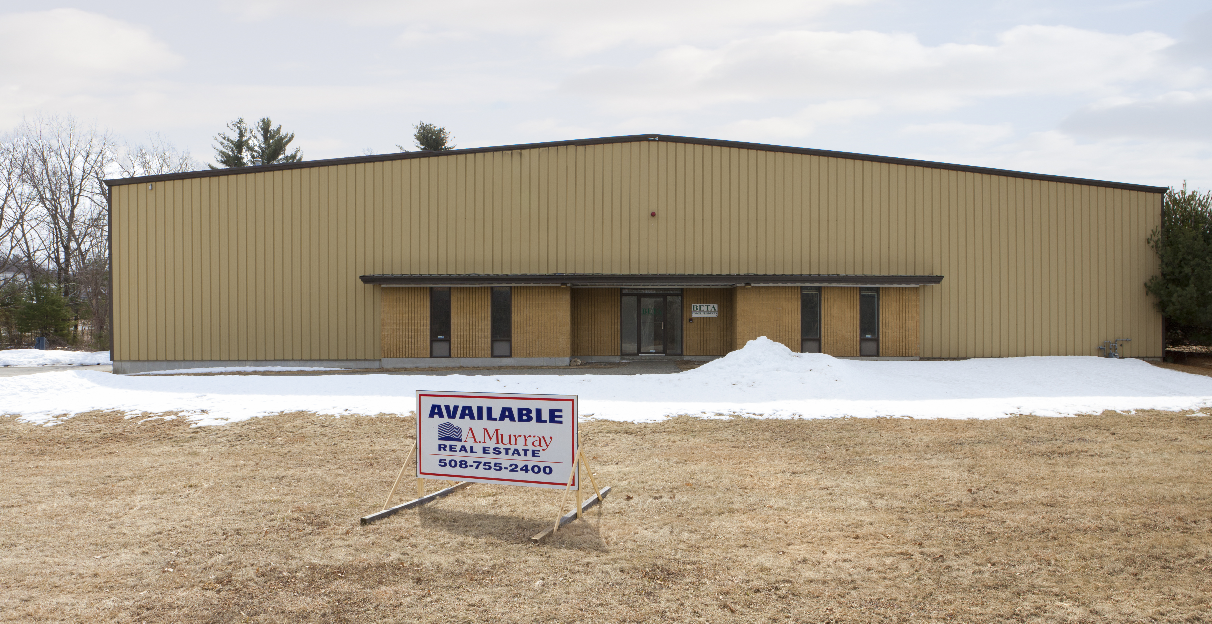

Part of 5 building site for sale in entirety

202 Bartlett Street Northboro, Ma A Murray Real Estate, LLC
37 Harvard Street Suite 109
Worcester, Ma 01609
+-12,000 sq ft warehouse w/ offices 508-755-2400
508-612-0082
1 loading dock and 1 drive in door

Gas heat

Dry sprinkler system

+-17’ - 20’ ceilings

Town Water,

Private septic

Convenient to Rte 9, Rte 495 and Mass Pike.

Information is from sources deemed reliable but has not been verified by the brokers. The real estate is offered subject to prior lease, sale or withdrawal without notice.

